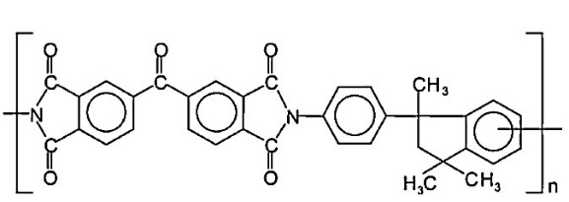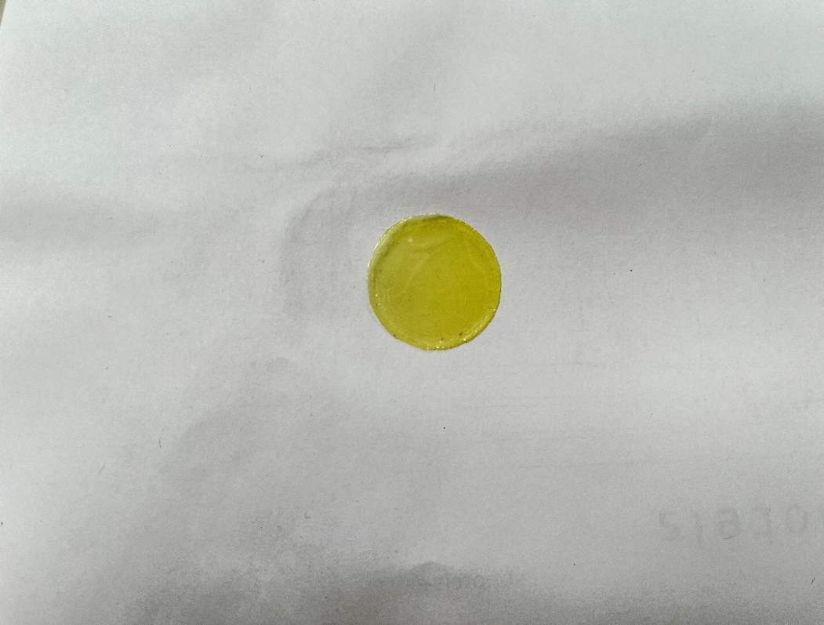
Fig. S1. Matrimid chemical structure and membrane tested in the test rig.

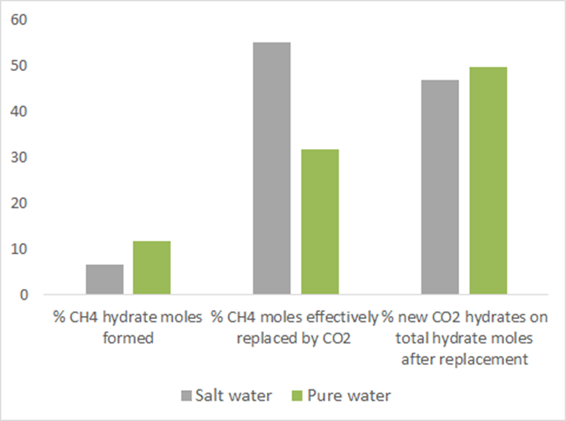

Fig. S2. Mass balances in presence of salt water and pure water.

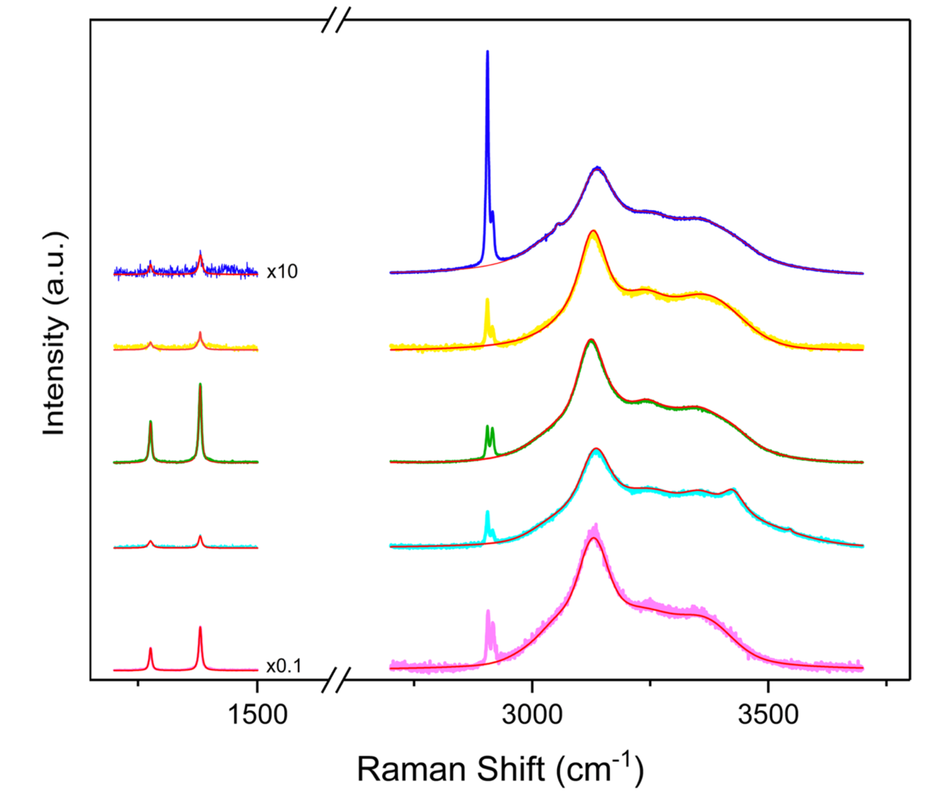
Fig. S3. Raman spectra of CO₂/CH₄-hydrate obtained by replacement process in artificial sand (yellow line), SDS (blue line), seawater (cyan line), natural sand (green line), and UP water (purple line). With permission from ref [46].
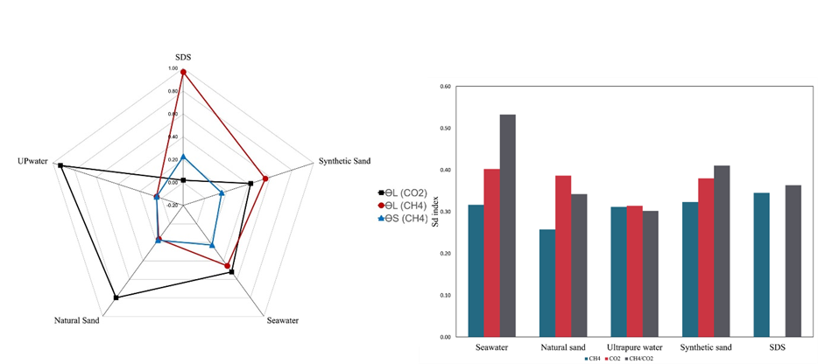

Fig. S4. Plot showing the CH₄ and CO₂ occupancy in the small and large cages and the relative ratio.(b) Comparison of the calculated SD index between CH₄-hydrate, CO₂-hydrate, and CH₄/CO₂-hydrate; (b) Figs modified with permission from ref [46].

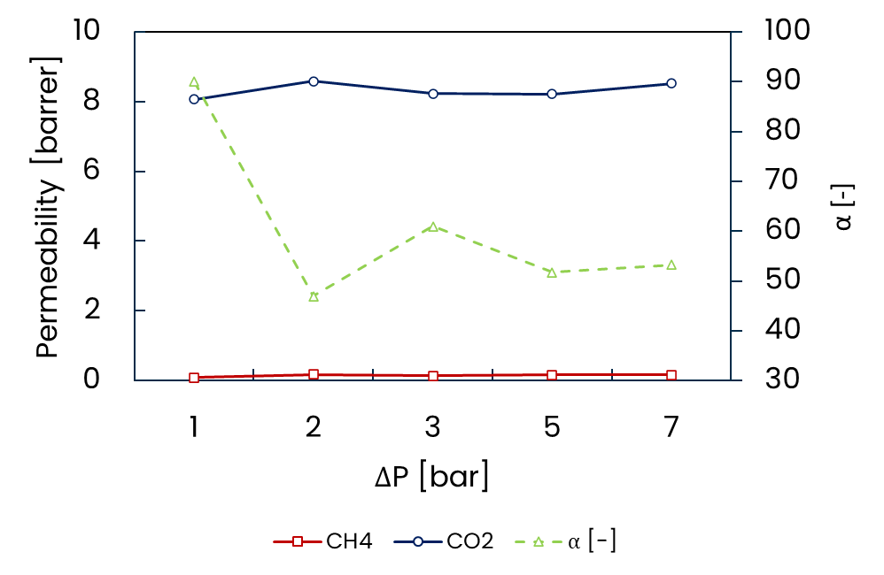
Fig. S5. Pure-gas permeability of CH₄ and CO₂ at 20°C on the left axis. Selectivity of the Matrimid membrane on the right axis.

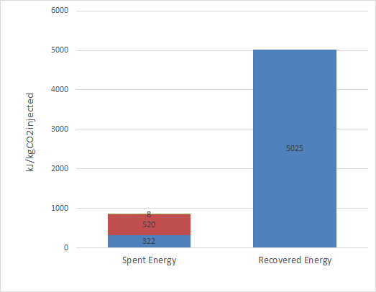
Fig. S6. Energy evaluations of the integrated process.

